ETL507 Professional reflective portfolio
Carolien Powell
ID 11684452
Word count: 3320

Part A

Statement of personal philosophy: what makes an effective teacher librarian
I believe as an effective teacher librarian (TL) I will guide students, staff, and the school community in understanding the value and importance of literature and being literate. I will instil a love of reading and literacy in students by sharing and promoting quality texts.
As an effective TL I will be implementing and supporting 21st century learning by giving students opportunities to develop these skills through critical thinking, collaboration, creativity, and communication. I will provide an inclusive, engaging, and safe space where students can learn and develop, in their own unique way.

Part B

Critical evaluation
Starting the Master of Teacher Librarianship in the beginning of 2019 coincided with working two days a week as Teacher Librarian (TL) at a small country school in the Hunter Valley. I was able to implement many of the practices I had been learning in my studies, not only in the library setting but also during my work as a classroom teacher.
The themes of information literacy, library management and promotion, and literature across the curriculum will form the basis of the portfolio as these have shaped my understanding and are in my opinion vital for efficient TLs.

Information Literacy
While starting this degree, the definition of literacy to me was simple: reading and writing. During the early days of ETL401 I was able to define this more into a “complex mix of listening, looking, reading, writing, comprehending and understanding” (Powell, 2019). Information literacy is even more involved than my previous definition. This is the reason the Australian School Library Association (ASLA) and the Australian Library and Information Association (ALIA) released a joint statement describing what information literacy means. The statement calls for a framework to ensure targeted skills are identified and taught within the context of the curriculum (ASLA & ALIA, 2016).
Being information literate means having an array of personal, social, and processing skills. ETL 504 gave me a great insight into the changing demands of the workplace, and the flow-on effect this has on the way we provide education. There is a global shift from a resource-based economy to a knowledge-based one (ASLA, 2013) and this has a profound impact on the jobs available and the skills the students will need. As TLs we are in the perfect position to teach students how to identify the need and purpose of information, how to use the information and how to reflect on and evaluate resources (Herring, 2017). The amount of information can be overwhelming, and students often do not know what quality and reliable information is. Information literacy can be incorporated in inquiry-based learning. An inquiry-based approach can teach students how to learn, deliver curriculum content, improve literacy competence, and develop social skills (Kuhltau, Caspari & Maniotes, 2012). To learn more about the way to teach information literacy through inquiry-based learning, I immersed myself in the model of Guided Inquiry Design (GID) during ETL401.
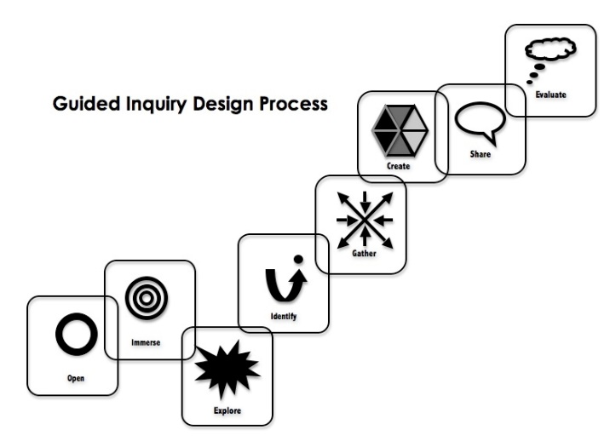
CC BY-SA-NC
To teach students the skills of the 21st century, we will need to give them the opportunities to develop their own questions, interests, and give them the tools to sift through the ever-growing amount of information. The article that really sparked my interest was Making the shift (Maniotes & Kuhltau, 2014). GID needs us as educators to shift from setting research assignments to designing learning experiences (Maniotes & Kuhltau, 2014). With the overwhelming amount of information, research can be difficult for students to master. This article highlights the need for students to discover, through inquiry, the real questions about topics, resulting into meaningful research. The eight phases of open, immerse, explore, identify, gather, create, share, and evaluate give students the possibility to experience a deeper learning experience. When I recently started ETL 501, my readings for a design proposal for a library led me to Thornburg’s (2013) learning spaces: campfire, watering hole, cave, and life. For me, the combination of GID and the four learning spaces makes perfect sense! Establishing spaces in the library for students to think critically, collaborate, and create fits with the GID.
The school curriculum seems to contradict itself when it comes to 21st century learning. There is a definite push to implement inquiry-based learning but at the same time the need and desire for standardised testing and data collection remains. Until this issue is resolved, inquiry-based learning will struggle to be implemented in schools.

Library management & promotion
Starting 2019 I became responsible for the library in a small school in the Hunter Valley. Coinciding with this, one of the first subjects I attempted was ETL503 Resourcing the curriculum. Resourcing the library was very necessary and the term weeding became a familiar term, for me this meant a critical evaluation of the collection and the removal of outdated, broken, or irrelevant resources. This evaluation of the collection was an important part for me to get to know the collection. In a blog post for ETL 503 (Powell, April 22, 2019) I outlined a basic plan to evaluate the collection and I used this plan to weed and assess the current collection. I found gaps in the collection with regards to fiction and non-fiction resources. Teachers were not using the library resources for their lessons due to the lack of relevance and there was no collaboration between the classroom teachers and the TL. Collaborating with teachers to plan, implement, and evaluate learning programs is mentioned in the library policy of the NSW Department of Education (2020). Through communicating with the teachers, I established which resources were required and I could suggest and purchase several titles to support the Geography curriculum.
The focus for me was to promote the love for reading. The impact of reading for pleasure on the overall development of children is well documented. It is more of an advantage to be an enthusiastic and frequent reader than to just have well-educated parents (Organisation for Economic Co-operation and Development [OECD], 2002). So, to establish social change education must find ways to engage students in reading (OECD,2002). The significance of this fact was and is startling to me. Educators need to provide students with the opportunities to read. I used Oliver to gain an insight into the borrowing patterns within the school and discovered the borrowing level of the students was extremely poor. This loan statistic shows the number of loans in 2018.
Loan Statistics by Bibliographic Type
from 29 Jan 2018 12:00:00 AM to 19 Dec 2018 11:59:00 PM
 | Copies Issued
Bibliographic Type
Book | 956
Magazine | 12
Website | 40
Total: | 1008
My mission was to get students to read! I developed a reward system where they received a stamp for every book borrowed. After 10 stamps students could choose a small prize and move to the next card. This created a huge buzz amongst the children! The teachers were supportive by encouraging borrowing in their classes. All prizes were book related, for example a bookmark, rubber, or a small book.
Promoting the library was one of my strategies to make the library and reading come alive for the school community. The National Simultaneous Story Time (NSS) event in May 2019 was an excellent opportunity to engage both students and the community. The book Alpacas with Maraca by Matt Cosgrove was the focus and a copy was purchased for the library. Through community engagement I organised an
actual alpaca to attend the school during the event. The children were surprised and extremely engaged!
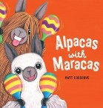
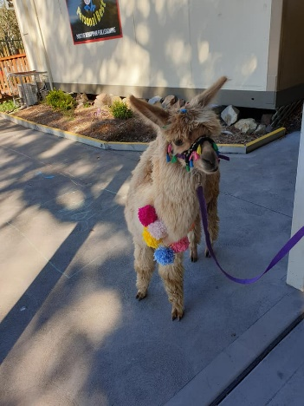 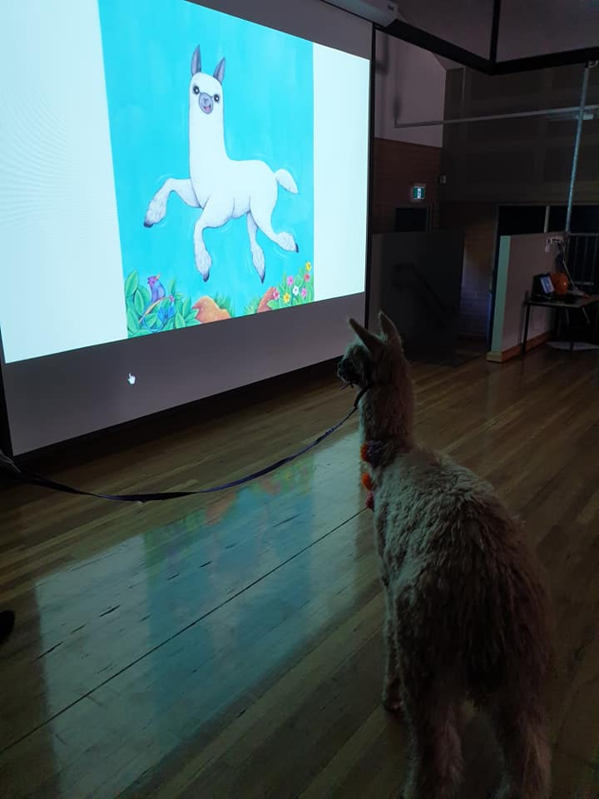 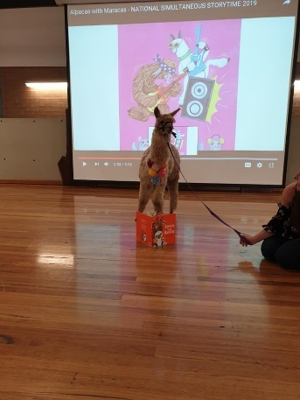 Photos by C.Powell
I also managed to secure a Scholastic Book Fair in Book Week. Promoting Book Week and the Book Fair by dressing up as a different book character every day gained lots of interest!
After promoting the library in various ways throughout the year, the result of my initial mission was evident. The students borrowed so much more and were engaged in the library and in reading!
Loan Statistics by Bibliographic Type
from 28 Jan 2019 12:00:00 AM to 18 Dec 2019 11:59:00 PM
 | Copies Issued
Bibliographic Type
Book | 3517
Magazine | 28
Search Source | 1
Website | 32
Total: | 3578

Literature across the curriculum
The reason for starting this degree is my love for books. The opportunity to use books within every subject of the curriculum has always been of interest since graduating as a teacher. My job as a Kindergarten teacher in The Netherlands saw me utilise books for projects and using them as the basis for activities across all learning areas, from literacy to maths, and from craft to physical education. This style of project-based learning is common practice in The Netherlands and one I thoroughly enjoyed. Throughout my teaching career in Australia I have encountered a small number of classroom teachers using books as the starting point for their literacy activities although this does not seem to be common. I have continued to develop lessons around books and incorporated a variety of curriculum areas. The book ‘Fantastic beasts and where to find them’ (Rowling, 2014) is a great example how a book can be used across curriculum areas. The following is a lesson plan for Stage 3.
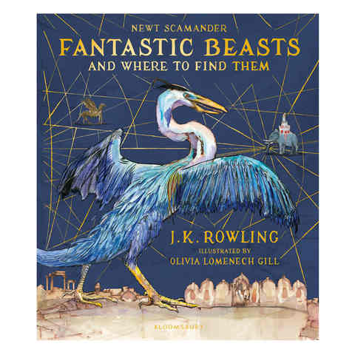

Fantastic Beasts | Stage 3
Outcomes
English K-10
- EN3-3A uses an integrated range of skills, strategies, and knowledge to read, view and comprehend a wide range of texts in different media and technologies
- EN3-7C thinks imaginatively, creatively, interpretively, and critically about information and ideas and identifies connections between texts when responding to and composing texts
- EN3-8D identifies and considers how different viewpoints of their world, including aspects of culture, are represented in texts
Geography K-10
- GE3-4 acquires, processes, and communicates geographical information using geographical tools for inquiry
Creative Arts K-6
- CA-VAS3.1 investigates subject matter to represent likenesses of things in the world
Mathematics K-10
- MA3-18SP uses appropriate methods to collect data and constructs, interprets and evaluates data displays, including dot plots, line graphs and two-way tables
English K-10
- EN3-5B discusses how language is used to achieve a widening range of purposes for a widening range of audiences and contexts

Content | Teaching, learning and assessment
Stage 3 - Thinking imaginatively, creatively, interpretively, and critically  Develop and apply contextual knowledge  - compare how composers and illustrators make stories exciting, moving and absorbing to hold readers' interest  Respond to and compose texts  - analyse and evaluate similarities and differences in texts on similar topics, themes, or plots (ACELT1614) | ‘Fantastic beasts and where to find them’ J.K.Rowling  Looking at cover, discuss which elements suggest the book is fiction and which suggest it is a non-fiction text. (complete notebook page)  Compare to Matt Chun's Australian Birds.  Discuss the effect of the inclusion of Ministry of Magic Classification page, contents, and index pages.
Stage 3 - Thinking imaginatively, creatively, interpretively, and critically  Engage personally with texts  - recognise and explain creative language features in imaginative, informative, and persuasive texts that contribute to engagement and meaning  - think critically about aspects of texts such as ideas and events | Read Billywig page. What techniques does the author use to engage the reader? Could this insect exist? Use the MOM classification system to 'level' the Billywig.  Look at Parks Australia webpage on Kata Tjuta. Discuss meaning of.gov.au and related reliability. Read information about Kata Tjuta and discuss the author's decision to reference a real place.  https://parksaustralia.gov.au/uluru/discover/highlights/kata-tjuta/
Geography: tools continuum S3 &bull; maps to identify location, distance, spatial distributions, and patterns  Stage 3 - Reading and viewing  Understand and apply knowledge of language forms and features  - analyse how text structures and language features work together to meet the purpose of a text (ACELY1711)  Respond to, read, and view texts  - navigate and read texts for specific purposes applying appropriate text processing strategies, for example predicting and confirming, monitoring meaning, skimming, and scanning (ACELY1702)  Stage 3 - Thinking imaginatively, creatively, interpretively, and critically  Understand and apply knowledge of language forms and features  - understand how authors often innovate on text structures and play with language features to achieve aesthetic, humorous and persuasive purposes, and effects (ACELA1518)  Respond to and compose texts  - create literary texts that adapt or combine aspects of texts students have experienced in innovative ways (ACELT1612, ACELT1618)  Stage 3 - Expressing themselves  Respond to and compose texts  - discuss aspects of literature from a range of cultures to explore common experiences and ideas as well as recognising difference | Read Dragon page. Use the MOM classification system to 'level' the Dragon. Introduce the 10 breeds of dragons and use their names to identify their country of origin. Use a world map to locate each country identified.  Discuss format of 'information' about each dragon (as per Matt Chun's Australian Birds. Compare with the format of The Slater Field Guide to Australian Birds). Identify the information listed about each bird and which elements are focused on i.e. name, size, physical description, voice, range.  Read Antipodean Opaleye. Identify the information we might list in a similar way to The Slater Field Guide to Australian Birds i.e. breed; habitat; diet; appearance; egg, flame. Model using a different coloured pencil to highlight information relevant to each element.  Model using the information collected to create a 'fact sheet' about the Antipodean Opaleye, including marking New Zealand on a world map & creating an illustration.  Read names of other dragon breeds and identify country of origin. Use prepared map (pinmaps.net) to look at location of dragon in the world. Discuss connections to two or more of: lore and legend of Vikings (Scandinavia: Sweden, Norway); Royal banner of Scotland and Welsh national flag (depict dragons); Chinese dragon dance (also lion dance); Temple of the Dragon (Peru); Slavic dragon myths (Ukraine, Hungary, Romania).  Students to choose an additional dragon breed and, using the same key, underline each element of information about the dragon i.e. breed; habitat; diet; appearance; egg, flame.  Students to use this information to create a 'fact sheet' (use template), including a world map and area for illustration.
VAS3.1 organise and assemble materials in various ways in the making of artworks suited to purposes and think about the  meaning of their decisions  Stage 3 - Reading and viewing  Respond to, read, and view texts  - use comprehension strategies to interpret and analyse information and ideas, comparing content from a variety of textual sources including media and digital texts (ACELY1703, ACELY1713)  - recognise how aspects of personal perspective influence responses to text | Look at Griffin, Hippogriff, Merpeople and Sphinx. All these 'beasts' have parts of at least 2 different animals and appear in Greek Mythology: they were not invented by JK Rowling. Discuss the purpose of including well known/existing 'beasts' in the book.  Discuss function of an encyclopedia and look at Britannica online. Identify elements that make it a reliable source. Read description of each 'beast' and compare to the one featured in FBaWTFT. https://www.britannica.com/  Using a page separated into three, draw an animal or character placing the head in the top segment, body and arms in the middle and legs (and tail) in the bottom segment. Teacher to create a 'flip book' by binding the pages and then cutting into segments.
Stage 3 - Reading and viewing  Understand and apply knowledge of language forms and features  - identify and explain how analytical images like figures, tables, diagrams, maps, and graphs contribute to our understanding of verbal information in factual and persuasive texts (ACELA1524) | Read Phoenix and locate countries of origin on world map. Discuss 'footnotes' and how they are used. Discuss what is means when it says 'see above' in the text.  Create a life cycle of a phoenix based on information and illustrations in Fantastic Beasts and Where to Find Them. Label each stage and include a heading.
Stage 3 - Data 1  Construct displays, including column graphs, dot plots and tables, appropriate for data type, with and without the use of digital technologies (ACMSP119)  - construct column and line graphs of numerical data using a scale of many-to-one correspondence, with and without the use of digital technologies  - name and label the horizontal and vertical axes when constructing graphs (Communicating)  - choose an appropriate title to describe the data represented in a data display (Communicating)  - determine an appropriate scale of many-to-one correspondence to represent the data in a data display (Reasoning)  Stage 3 - Responding and composing  Develop and apply contextual knowledge  - investigate how the organisation of texts into chapters, headings, subheadings, home pages and subpages for online texts and according to chronology or topic can be used to predict content and assist navigation (ACELA1797) | Discuss how the beasts are ordered in the book (alphabetically). Identify other texts that use this method of organisation (dictionaries, encyclopedias, telephone book - all NF). Students to organise a list of the names of the beasts alphabetically.  Students to suggest alternate ways to organise the information e.g. geographical location of beast; MOM classification; air/water/land dwelling etc. Choose one alternate organisational method create a graph to display the beasts in this way.

This form of literary learning supports learning in other curriculum areas and enables greater comprehension and the use of assumptions and implications (Haven, 2007). I want students to understand that other worlds and times are different from the one familiar to them (Cornett, 2014). In my Reflective post ETL 402, (Powell, 2020). I explore the importance of the use of stories and how they can be used to motivate, teach, and communicate information and concepts (Haven, 2007). Students need to think critically and incorporating a fictional text to facts can add different layers of meaning.
Using picture books for all students in primary school is a great underused resource. Fiction provides a range of engaging and meaningful learning opportunities. Combining fiction with information provides an interesting dimension to picture books. I had the pleasure of meeting Claire Saxby and believe her work is a great example of a beautiful collaboration between fact and fiction. This style works well in engaging younger students while providing information for older ones. I used her book Dingo to teach students facts about dingos while evoking compassion and empathy through the fictional story.
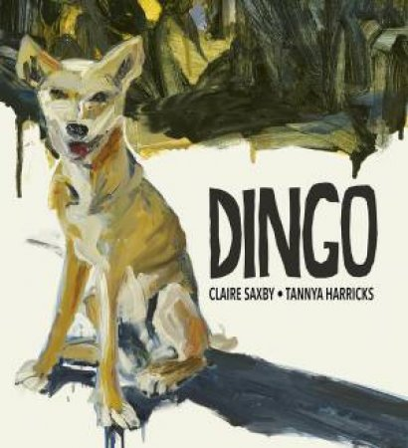
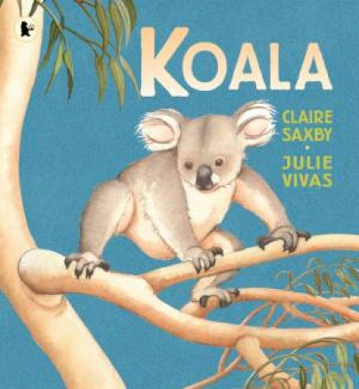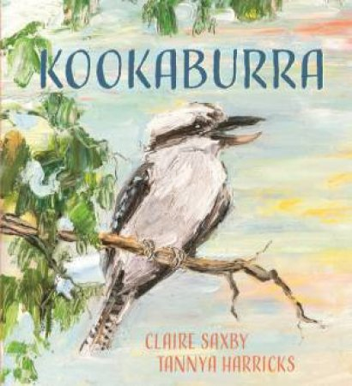
I have been surprised by the number of quality picture books available for older readers. Engaging students, especially reluctant readers, can be accomplished by providing them with books containing quality visual images.

Part C
During this degree, I have developed a greater understanding of the role of the TL in primary schools. The Standards of professional excellence for teacher librarians (2004) are a useful guide for the TL community and for me as a professional to continue to develop my skills. For Standard 1 Professional knowledge, I believe my experience as a teacher provides me with substantial knowledge regarding the curriculum. I will continue to review current and new syllabuses to keep my knowledge up to date. I would like to undertake more professional development in the areas of technology and library management. I am keen to learn more about connected classrooms, digital resources, and Oliver.
I believe Standard 2 Professional practice, is a continuing process. I can provide students with a supportive and engaging library as my creative displays and quality programs are of a high standard. My aim is to work more collaboratively with the class teachers, to incorporate the library programs in the class programs instead of them being separate. I will undertake more professional learning regarding inquiry-based learning and the integration of this pedagogy into teaching.
Looking at Standard 3, I feel I have strong professional commitment to the profession. I attend my local Primary Teacher Librarian Network meetings every term as it is a great way to learn from other TLs. I have also attended the MANTLE conference in 2019, providing me with great ideas and the opportunity for networking. I look forward to continuing my professional development as TL this year and beyond. Reflecting and evaluating on my work as a TL is an ongoing process and one that I am looking forward to doing for years to come!

References
Australian Library and Information Association. (2016). ALIA/ASLA policy on information literacy. Retrieved from Australian Library and Information Association: https://www.alia.org.au/about-alia/policies-standards-and-guidelines/aliaasla-policy-information-literacy-australian-schools
Australian Library and Information Association. (2004). Standards of professional excellence for teacher librarians. Retrieved from Australian Library and Information Association: https://www.alia.org.au/about-alia/policies-standards-and-guidelines/standards-professional-excellence-teacher-librarians
Australian School Library Association.(2013). Future learning in school libraries. Retrieved from Australian School Library Association: https://asla.org.au/resources/Documents/Website%20Documents/Resources/2013-ASLA-futures-paper.pdf
Cornett, C. (2014). Integrating the literary arts throughout the curriculum. In Creating meaning through literature and the arts : arts integration for Classroom teachers (5 ed., pp. 144-193). Upper Saddle River, Prentice Hall.
Haven, K. (2007). Story proof: The science behind the startling power of story. Retrieved from https://ebookcentral.proquest.com/lib/CSUAU/detail.action?docID=329134
Herring, J. (2017). The future role of the teacher librarian. Connections(100). Retrieved from https://www.scisdata.com/connections/issue-100/the-future-role-of-the-teacher-librarian/
Kuhlthau, C., Maniotes, L., & Caspari, A. (2012). Guided Inquiry Design: A framework for inquiry in your school. Santa Barbara, California: Libraries Unlimited.
Maniotes, L., & Kuhltau, C. (2014). Making the shift. Knowledge Quest, 43(2), 8-17. Retrieved from https://search-proquest-com.ezproxy.csu.edu.au/docview/1620878836?accountid=10344
NSW Department of Education. (2020). Library policy. Retrieved from Policy library: https://policies.education.nsw.gov.au/policy-library/policies/library-policy-schools
Organisation for Economic Co-operation and Development. (2002). Reading for change. Retrieved from www.pisa.oecd.org
Powell, C. (2019). The collection evaluation. Retrieved from Thinkspace: https://thinkspace.csu.edu.au/carolien/2019/04/22/the-collection-evaluation/
Powell, C. (2020). Part B Reflective blogpost. Retrieved from Thinkspace: https://thinkspace.csu.edu.au/carolien/category/etl-402/
Rowling, J. (2017). Fantastic beasts and where to find them. Bloomsbury Publishing.
Thornburg, D. (2013). From the campfire to the holodeck : Creating engaging and powerful 21st century learning environments. Retrieved from http://web.a.ebscohost.com.ezproxy.csu.edu.au/ehost/ebookviewer/ebook/bmxlYmtfXzY0NTA2N19fQU41?sid=ecc619fa-6681-4007-bfc4-957d7baff7a0@sdc-v-sessmgr03&vid=0&format=EB&rid=1

