CREATIVE COMMONS
Creative Commons provide free licenses to creators, to tell people how they want their work to be used.

Work can be shared and reused legally.

The symbols used by Creative Commons and what they mean
Attribution  BY | NonCommercial  NC | No Derivative Works  ND | Share Alike  SA
This applies to every Creative Commons work. Whenever a work is copied or redistributed under a Creative Commons licence, the original creator (and any other nominated parties) must be credited and the source linked to. | Lets others copy, distribute, display and perform the work for noncommercial purposes only. | Lets others distribute, display and perform only verbatim copies of the work. They may not adapt or change the work in any way. | Allows others to remix, adapt and build on the work, but only if they distribute the derivative works under the same the licence terms that govern the original work.

Retrieved from https://creativecommons.org.au/learn/licences/

The six different variations of the Creative Commons licenses
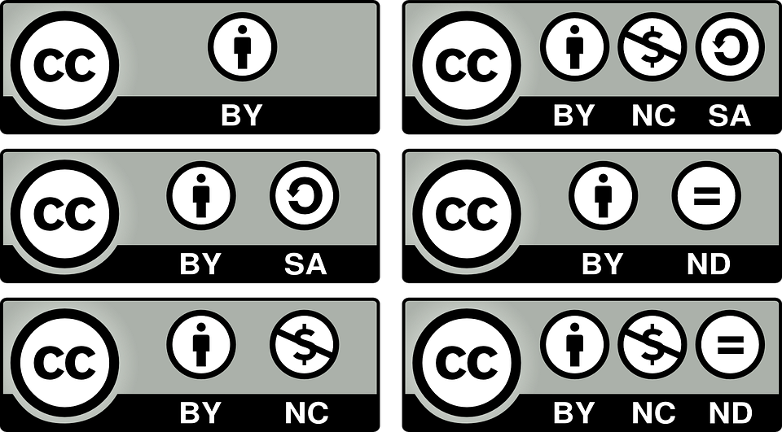

Where to find the Creative Commons resources
Retrieved from https://creativecommons.org.au

Source | Description | Content types | Website
Flickr | A photo distribution service with over 90 million CC licensed photos and videos. These can be accessed via the main site or through a dedicated portal. | Images, video | flickr.com/creativecommons
Open Photo | A moderated photo community with thousands of CC licensed photos in various categories. | Images | openphoto.net
Picture Australia | Australian themed images hosted by the National Library of Australia. Some images are CC licensed or in the public domain. | Images | pictureaustralia.org
CC Mixter | CC sound remix tool and archive. A good source of CC music. All the music on CC Mixter can be remixed | Music | ccmixter.org
Freesound | A good source of sound effects and background noises, all available for reuse. | Sounds | freesound.org
Blip.tv | A video sharing site that includes a lot of CC licensed material. | Video | blip.tv
Engage Media | An Australian-based site which distributes videos about social justice and environmental issues in the Asia Pacific. All videos are CC licensed. | Video | www.engagemedia.org
ABC Pool | A multimedia site run by the Australian Broadcasting Corporation that includes lots of CC-licensed user-generated video, music, art and text, as well as increasing amounts of reuseable material from ABC’s own archives. | Images, video, music, text | pool.abc.net.au
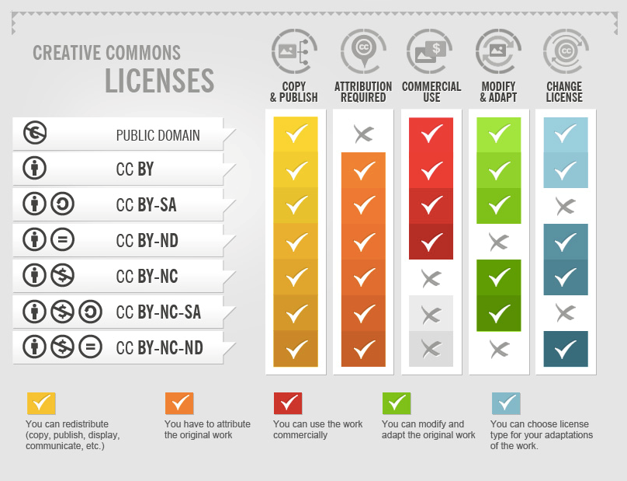
This Photo by Unknown Author is licensed under CC BY
When attributing a work under a CC license you should:
- Credit the creator;
- Provide the title of the work;
- Provide the URL where the work is hosted;
- Indicate the type of license it is available under and provide a link to the license (so others can find out the license terms); and
- Keep intact any copyright notice associated with the work.

